Checklists for theses submitted to the EDI saúde
(Agreement of the CA of February 7, 2019)

Checklists for theses submitted to the EDI saúde
Theses presented for evaluation by the EDI Saúde from the 2nd of May, 2019, should attach the following checklists:
- General checklist for EDI saúde. For all Theses presented. This list covers the formal requirements that have been requested so far. It will allow doctoral students to ensure that they meet the formal requirements. It will also help the academic committee control them.
- Depending on the type of thesis, at least one specific checklist:
  - STROBE list if the Thesis includes observational studies.
  - CONSORT list if the Thesis includes clinical trials.
  - ARRIVE list if the thesis includes animal experimentation.
  - The list of statistical analysis if no specific list applies.
The lists respond to broad consensus in each of the fields, have contributed to improve the quality of the research work in the respective fields, and are intended to serve as a guide to improve the quality of the theses. Please be aware that the lists must be covered but that at this moment the approval of the thesis does not depend on the fulfillment of each item on the list. As up to now, this will be the decision of the academic commission of the school for each specific thesis.

Santiago de Compostela, 7 of February de 2019
Director of the EDI in Health Sciences
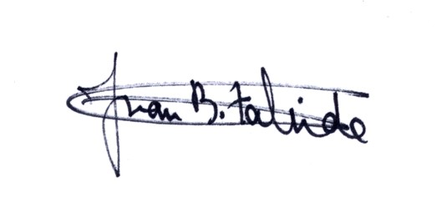

Juan Bautista Zalvide Torrente

